**Assignment** [**8.5**](https://github.com/SomanathSankaran/assmt-8.5)

**Download and import HDP into your virtual box and explain how Ambari is useful and the features of Ambari.**

**Step1: Installing Ambari**

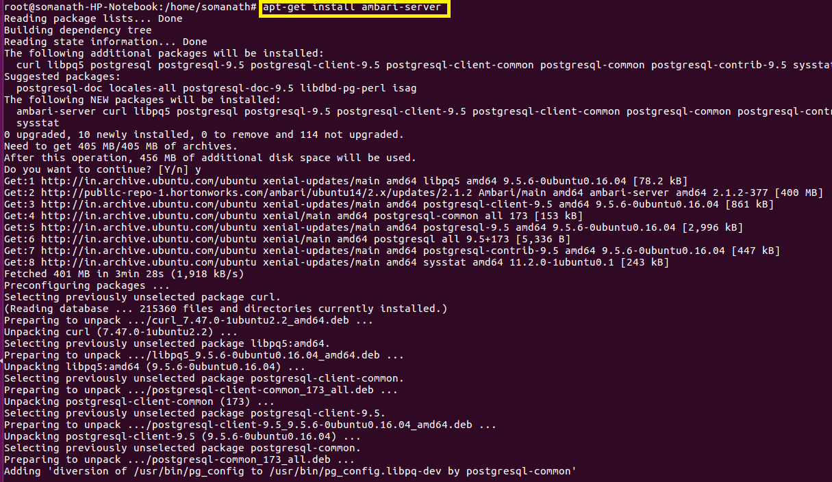

**Step 2: Setting Up Ambari Server**

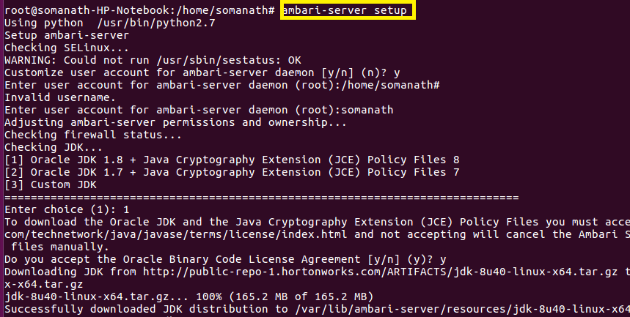

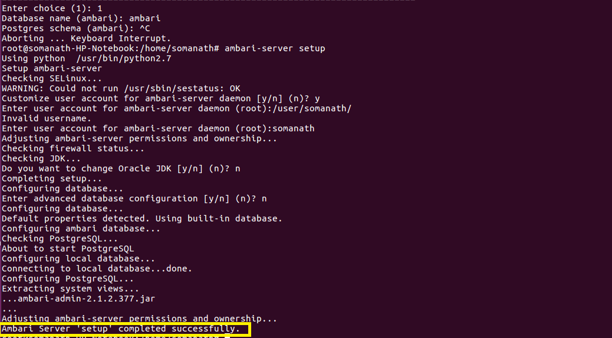

**Features of Ambari:**

The Apache Ambari project is aimed at making Hadoop management simpler by developing software for provisioning, managing, and monitoring Apache Hadoop clusters. Ambari provides an intuitive, easy-to-use Hadoop management web UI backed by its RESTful APIs.

Ambari enables System Administrators to:

* Provision a Hadoop Cluster
  + Ambari provides a step-by-step wizard for installing Hadoop services across any number of hosts.
  + Ambari handles configuration of Hadoop services for the cluster.
* Manage a Hadoop Cluster
  1. Ambari provides central management for starting, stopping, and reconfiguring Hadoop services across the entire cluster.
* Monitor a Hadoop Cluster
  1. Ambari provides a dashboard for monitoring health and status of the Hadoop cluster.
  2. Ambari leverages **Ambari Metrics System** for metrics collection.
  3. Ambari leverages **Ambari Alert Framework** for system alerting and will notify you when your attention is needed (e.g., a node goes down, remaining disk space is low, etc).

Ambari enables Application Developers and System Integrators to:

* Easily integrate Hadoop provisioning, management, and monitoring capabilities to their own applications with the **Ambari REST APIs.**